**Ideation Phase**

**Empathize & Discover**

| Date | 16 February 2026 |
| --- | --- |
| Team ID | LTVIP2026TMIDS89357 |
| Project Name | Explore with Ai: custom itineraries for your next journey |
| Maximum Marks | 4 Marks |

**Empathy Map Canvas:**

Creating an effective travel solution powered by AI requires understanding the traveler’s true goals, motivations, and challenges. The empathy mapping process helps designers and teams step into the traveler’s mindset, ensuring that AI-generated itineraries are personalized, relevant, and meaningful.

With **Explore with AI**, custom itineraries are designed around the traveler’s unique preferences, helping them discover destinations, experiences, and journeys that truly match their expectations.

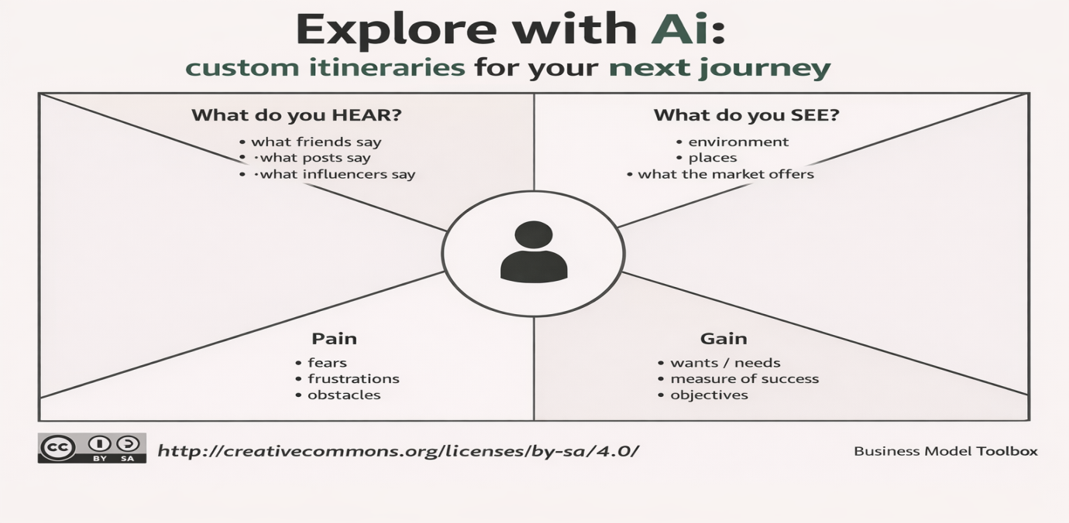

This empathy map illustrates a traveler who wants a personalized and stress-free travel planning experience. The traveler hears recommendations from friends, influencers, and online reviews, and sees many destination options, travel deals, and itinerary suggestions in the market. They feel excited about exploring new places but may also feel overwhelmed by too many choices and the effort required to plan everything. They search online, compare options, and look for solutions that match their preferences, budget, and time. Their main challenges include time-consuming research, confusion from too much information, and fear of missing the best experiences. Their goal is to have a smooth, enjoyable, and memorable journey with a customized plan that fits their needs. Explore with AI addresses these needs by creating smart, personalized itineraries that simplify travel planning and help travelers confidently explore the world.

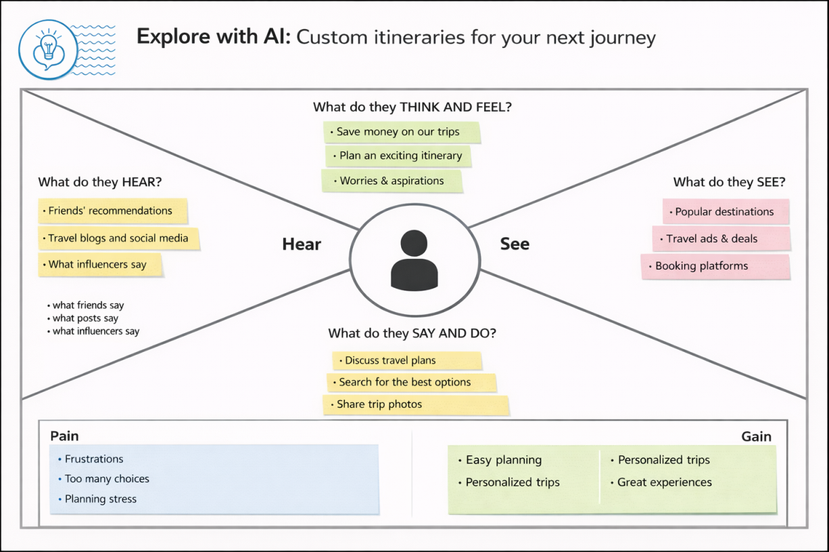

Travelers often think and feel excited about exploring new destinations but also feel stressed about planning the perfect trip within their budget and time. They hear recommendations from friends, family, travel bloggers, and social media influencers, which influence their decisions and expectations. They see many travel websites, advertisements, and destination options online, which can sometimes be overwhelming. Travelers usually search multiple platforms, compare options, and discuss plans with others before making decisions.